Motion Analysis

Four motion studies were performed for the Swiss Army Knife using Solidworks to test its basic operations. The studies observed the case door opening and closing, the upper and lower utensils releasing and retracting, and the two separate assembly cases separating and attaching. Only parts and mates relevant to these individual operations were considered - all others were suppressed for the sake of calculation efficiency. The following source was used to determine appropriate values for actuating forces: <https://ergoweb.com/force-guidelines/>.

Case-to-Case Separation and Attachment

The design consists of two separate assemblies - one containing a spoon and knife, another containing a fork and can opener. The two case assemblies are attachable via a sliding channel on their sides. A path mate and path mate motor were used to simulate detaching and reattaching. Figure 1 below shows that an approximate sliding distance of 4 inches is required to detach the cases from one another.

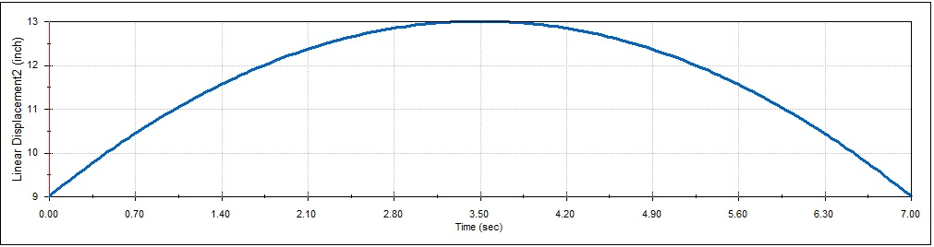

Figure 1: Case Separation Linear Displacement

Door Opening and Closing

The door used a torsional spring (k = 0.03 lbf-in/deg, free angle = 180 deg) to simulate automatic opening. The door lock used a linear spring (k = 11.4 lbf/in, c = 5.7 lbf/in/s) to keep the lock extended downward. A linear actuating force (F = 0.5 lbf) pushed the door lock against its spring which allowed the door to unlatch and travel to the open position. A torque (T = 8.9 lbf-in) was used to close the door where the door lock spring and latch geometry maintained the door in the closed position. Figure 2 below shows that a door lock displacement of 0.04 inches is required to open the door.

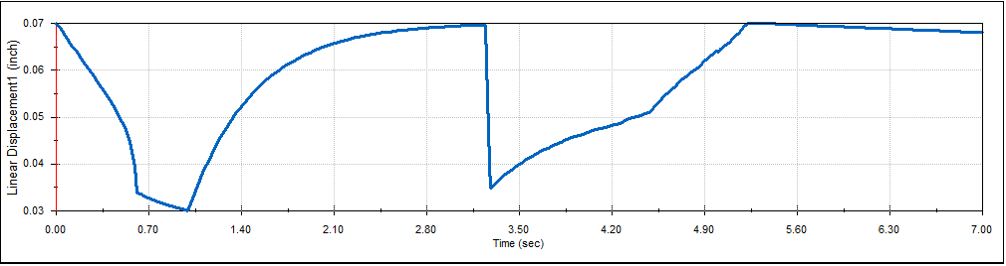

Figure 2: Door Lock Linear Displacement

Knife Release (Upper Utensil)

The upper utensil lock used a linear spring (k = 68 lbf/in) to keep the knife locked in the retracted or released position via a hole in the knife body. The knife used a torsional spring (k = 0.02 lbf-in/deg, free angle = 180 deg) to simulate automatic utensil release. A linear force (F = 2.7 lbf) was used on the tool release tab which allowed the knife to travel to the released position. A torque (T = 3.5 lbf-in) was used to retract the knife and was held in position by the utensil lock cantilever. Figure 3 below shows contact force between the upper utensil lock cantilever and the knife body hole, with a maximum resting value of approximately 12 lbf in the retracted position.

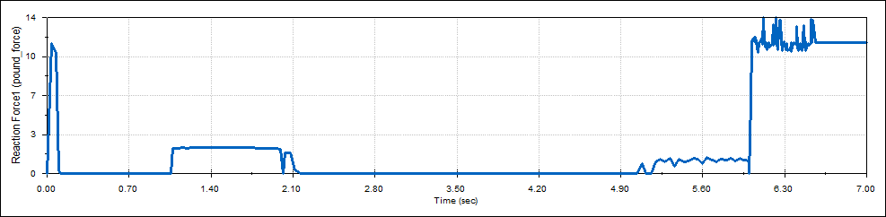

Figure 3: Upper Utensil Lock Cantilever to Knife Body Hole Contact Force

Spoon Release (Lower Utensil)

The lower utensil lock used a linear spring (k = 68 lbf/in) to keep the spoon locked in the retracted or released position via a hole in the spoon body. The spoon used a torsional spring (k = 0.03 lbf-in/deg, free angle = 180 deg) to simulate automatic utensil release. A linear force (F = 2.7 lbf) was used on the tool release tab which allowed the spoon to travel to the released position. A torque (T = 5.3 lbf-in) was used to retract the spoon and was held in position by the utensil lock cantilever. Figure 4 below shows contact force between the upper utensil lock cantilever and the spoon body hole, with a maximum resting value of approximately 18 lbf in the retracted position.

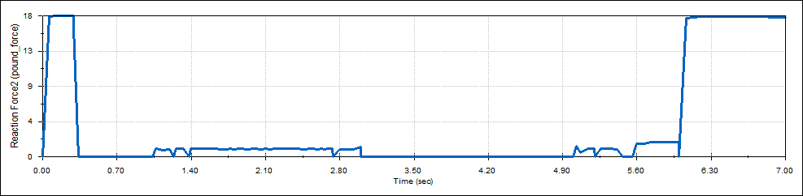

Figure 4: Lower Utensil Lock Cantilever to Spoon Body Hole Contact Force